**Getting Started: Save As DAISY for Office 2010**

1. Uninstall any previous beta copies of Save As DAISY that you might have installed. Go to Control Panel | Programs and Features (or by Category - Control Panel | Uninstall a Program) and select DAISY Translator Add-in to uninstall.
2. Install “Save As DAISY for Office 2010” add-in software from <http://sourceforge.net/>.
3. “Save As DAISY” will show up in your Start menu as “DAISY Translator”. In this folder will be the following files:
   * Getting Started Document
   * Accessibility Demo File
   * Daisy Translator Help files

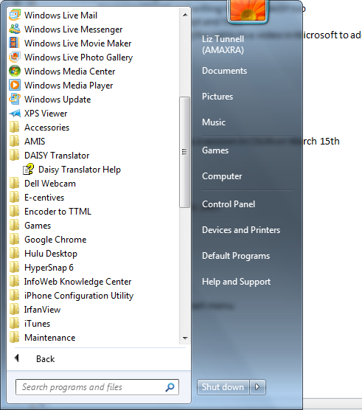

1. Install a DAISY-compatible digital talking book reader, such as the free AMIS reader, in order to use your DAISY output files: [http://www.DAISY.org/amis/download](http://www.daisy.org/amis/download)
2. Open the sample document “Accessibility_demofile.docx.”
3. Notice that the document, which describes the accessibility checker in Office 2010, contains a number of different elements: Titles and subtitles, tables, and pictures with captions. This demonstration will show how you can take this Open XML document and easily convert it to a DAISY standard digital talking book.
4. Notice on the HOME tab at the top, on the right hand side is an Accessibility tab. Click on this tab.

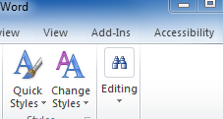

1. Take a look at the many options available on the Accessibility toolbar.

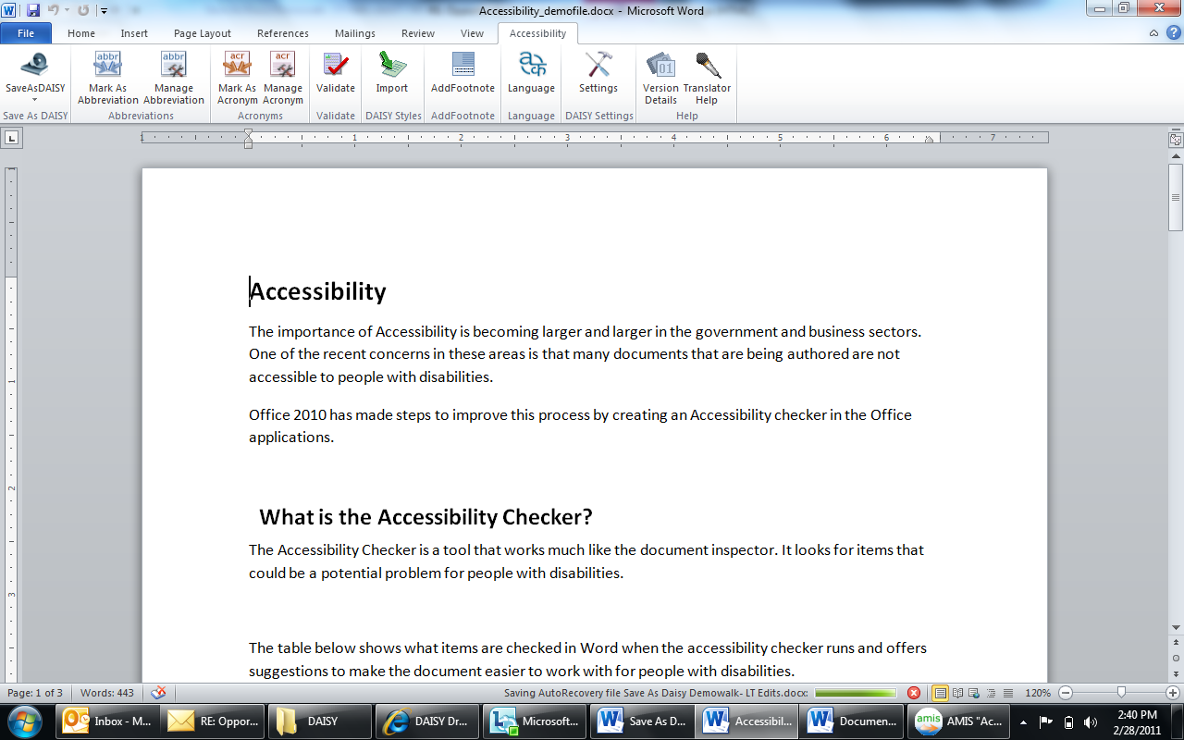

1. Save the document as you normally would as it is always a good idea to save your document before you get started.
2. Click on Validate button on the accessibility ribbon.

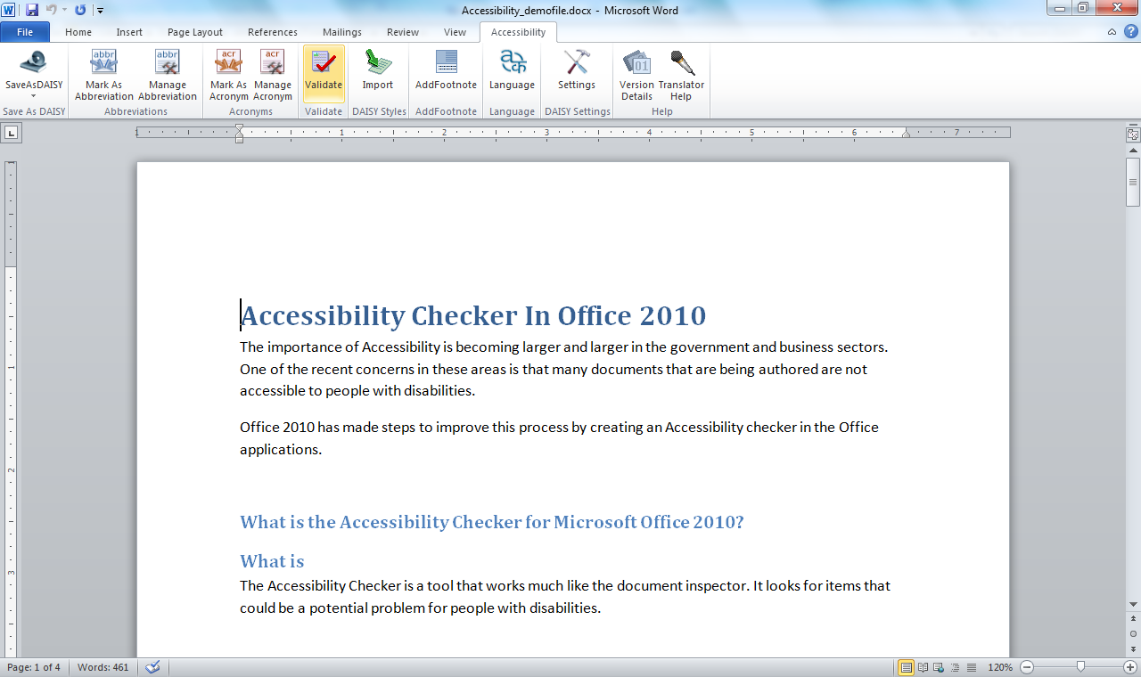

You should get a validation error in this demo file because the add-in determined that the document violates one of the navigational rules for DAISY Digital Talking Books. If you read the error message and scroll down, you’ll see there is some errant text underneath Heading #2 “What is the Accessibility Checker for Microsoft Office 2010”. This is followed by redundant text at the same level saying “What is”. The add-in will not allow you to make this mistake since it would impact navigation of the talking book. Delete “What is” and save again, then try to validate once more. Now you should have no errors.

1. Next, we’ll create a Digital Talking Book in DAISY format. There are many ways to do this, as you can see if you click on the Save As DAISY tab on the ribbon interface. You see four choices:
   * DAISY XML from Single .docx
   * Full DAISY from Single .docx
   * DAISY XML from Multiple .docx
   * Full DAISY from Multiple .docx.

We encourage you to try them all, but for the time being since we will be using the DAISY AMIS reader for this demonstration, we’ll focus on “Full DAISY from Single .docx.” Now that you have saved the document, you’re ready to Save As DAISY.

1. Click on the second option under Save As DAISY, “Full DAISY from Single .docx/Narrator to DT Talking Book” and watch the conversion process begin. It’s very speedy, although the longer the document and more sources used, the longer the processing time will be.

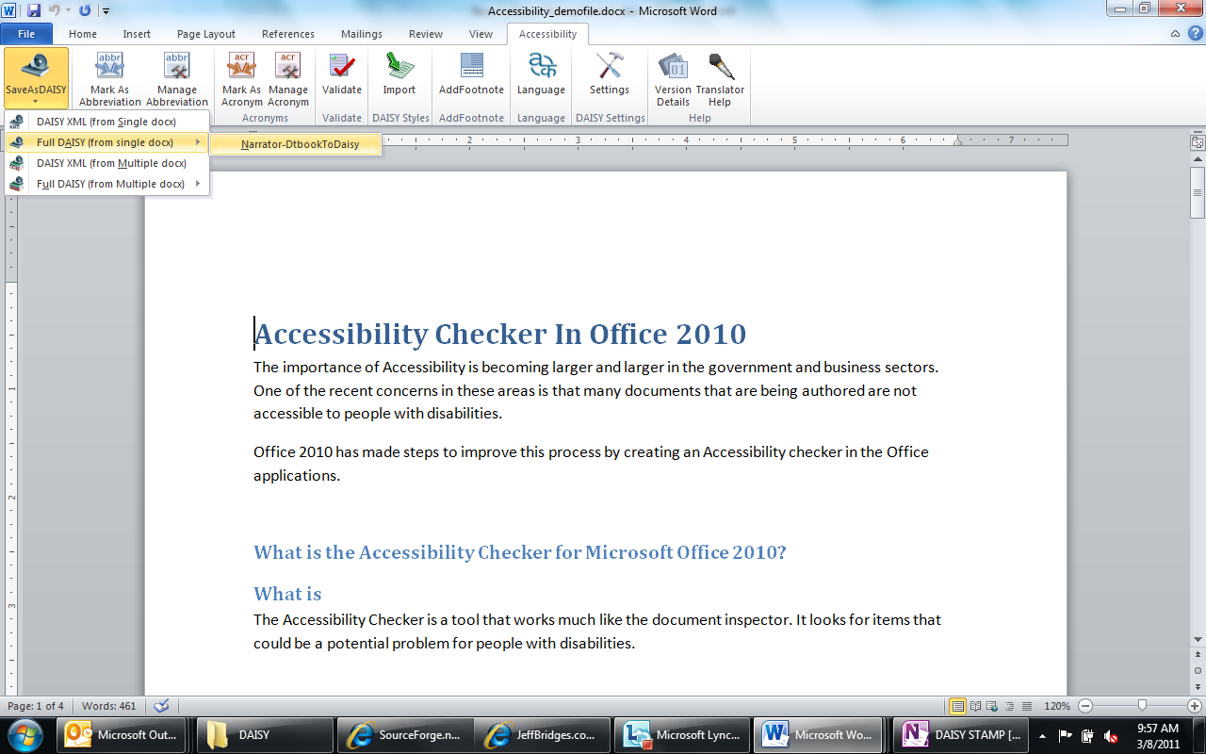

1. Choose a source directory for the output files. If you click the Browse button, it will allow you to either select a location or create a new folder where your files will be placed. If you pick an existing directory with files in it, you will be given an option to clean it. We don’t suggest you do that as it will eliminate existing files in the directory and is used mainly when users are re-running or updating a project.

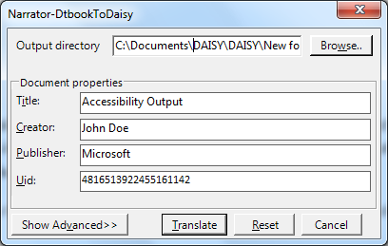

1. When the project is complete, you will get a message that says “Job Completed.”
2. Now it’s time to launch your DAISY reader. You should have already installed AMIS, the free, PC-based DAISY reader from the DAISY.org site. Go ahead and launch AMIS or your preferred DAISY reader.
3. Next click FILE ->OPEN and open the location of your saved and converted file. You should see a “DAISY 202” subdirectory. Click on that directory and you will see a ncc.html file. Select that and click Open. Once the file opens you will be presented with an interface that looks something like this:

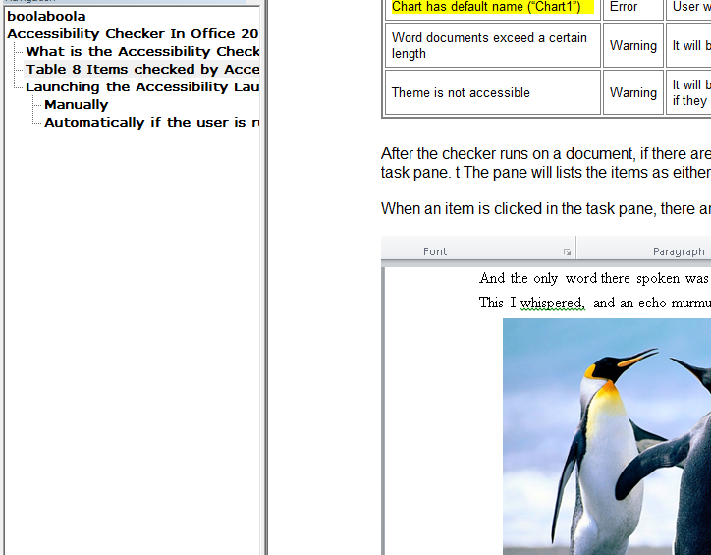

1. On the left hand side is a hierarchical view of the various titles, tables, and charts in the document, on the right is the reading pane which will highlight the text as it’s being read. You might want to hit the space bar to pause the reader at this point and get your bearings. Feel free to click on any of the hierarchical selections in the left pane to instantly navigate to those sections. Note: all of your tables, pictures, captions, and titling were automatically translated by the Save As DAISY add-in and DAISY pipeline software. You can now listen to the Accessibility document in the DAISY format from the AMIS reader.

**Note:** We have shown you only a single example of DAISY reader software in this demonstration. There are many readers available in the market in many different formats; free, paid, software-based and hardware-based. Visit [www.DAISY.org](http://www.Daisy.org) for a complete listing.